CH Grocers

Management Interface Guide

This management interface guide will control you through the features of the dashboard and will likewise enable you to explore through the management dashboard effortlessly. Likewise, to ensure you don't have the problem of perusing long, exhausting and pointless aides, we've attempted our best to make this short, straightforward and justifiable. In the event that you have any further inquiries that the guide couldn't deliver please don't hesitate to get in touch with us on [chgrocers123@gmail.com](mailto:chgrocers123@gmail.com)

# Management Interface Login

You can log in as and admin if you are given access by the team of developers. You can see a management login option where you can enter the right credentials to login.

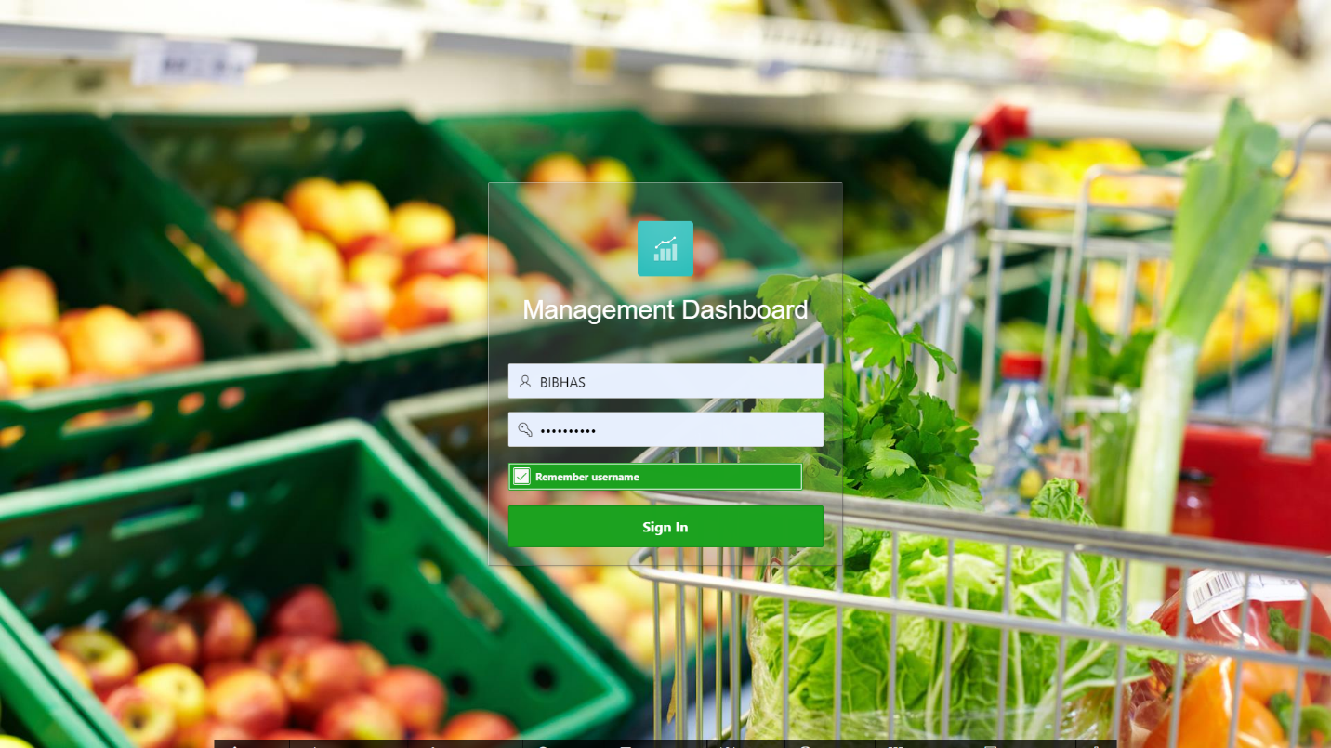

# Management Dashboard

You can view the reports on products, categories and sales on the management dashboard.

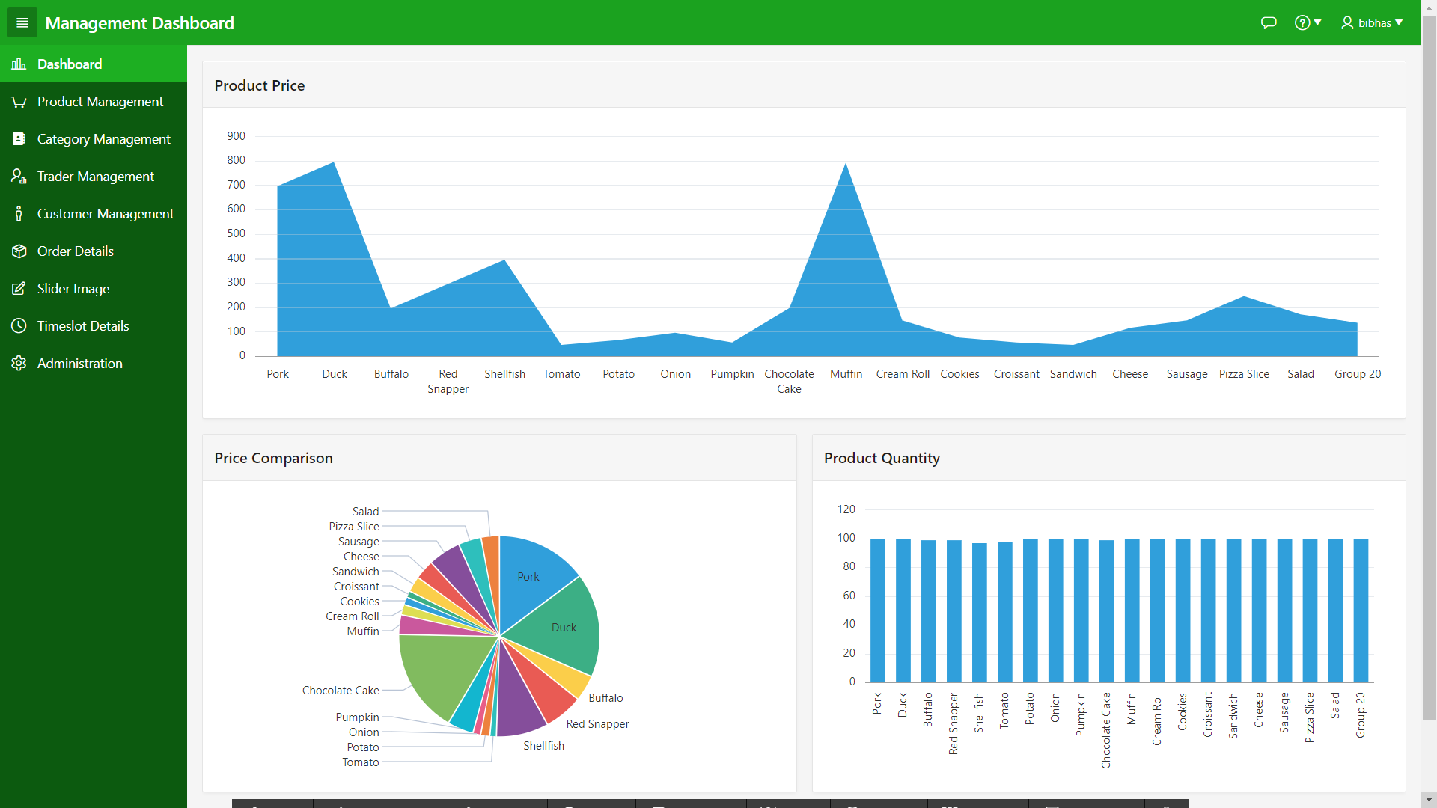

# Product Management

You can view the interactive report on the product management page where you have the option to add new product or edit existing product.

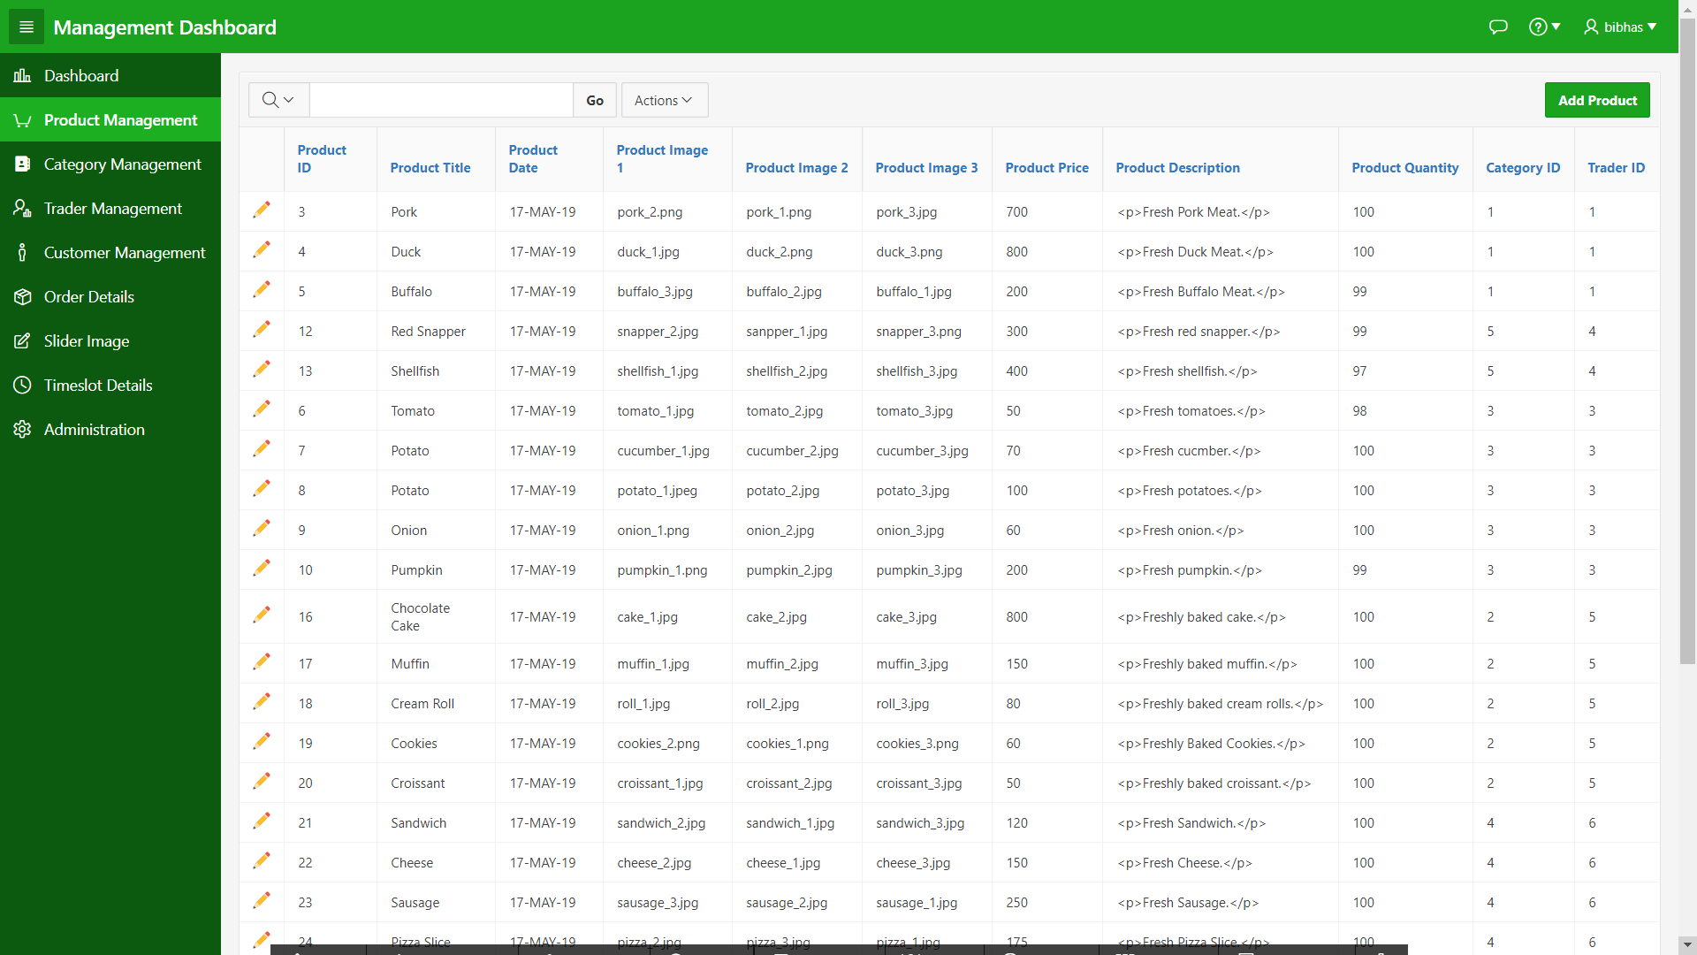

# Edit Product

You can edit the product after clicking on the pencil icon. A modal dialog page opens where the product can be edited.

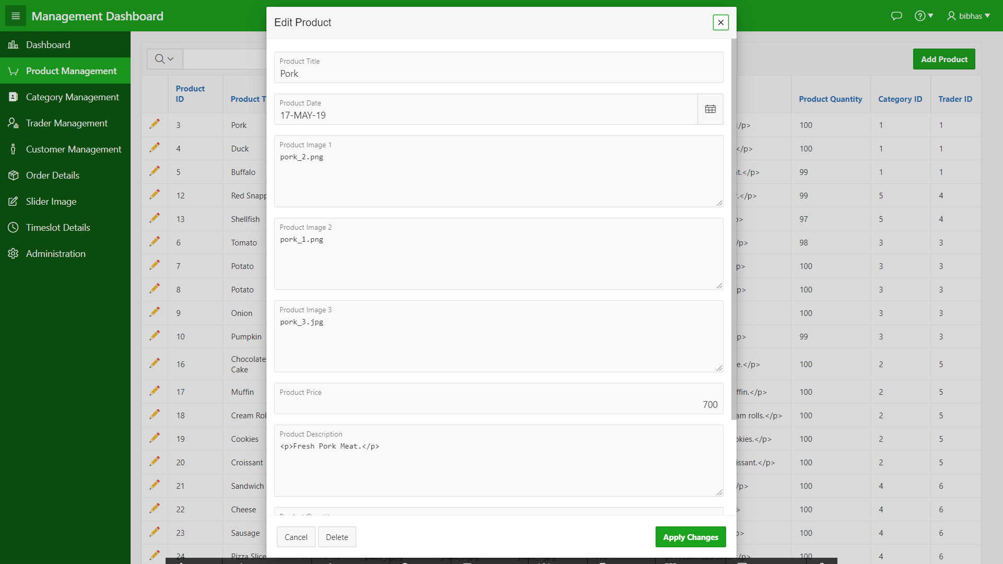

# Category Management

You can view the interactive report on the category management page where you have the option to add new category or edit existing category.

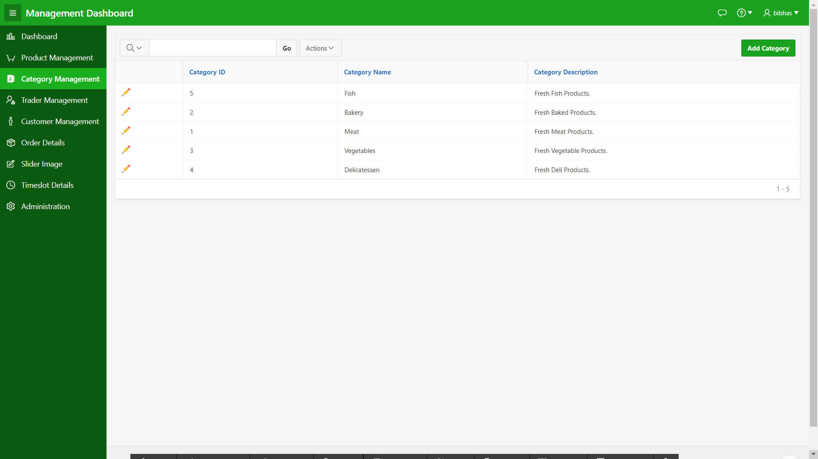

# Edit Category

You can edit the category after clicking on the pencil icon. A modal dialog page opens where the category can be edited.

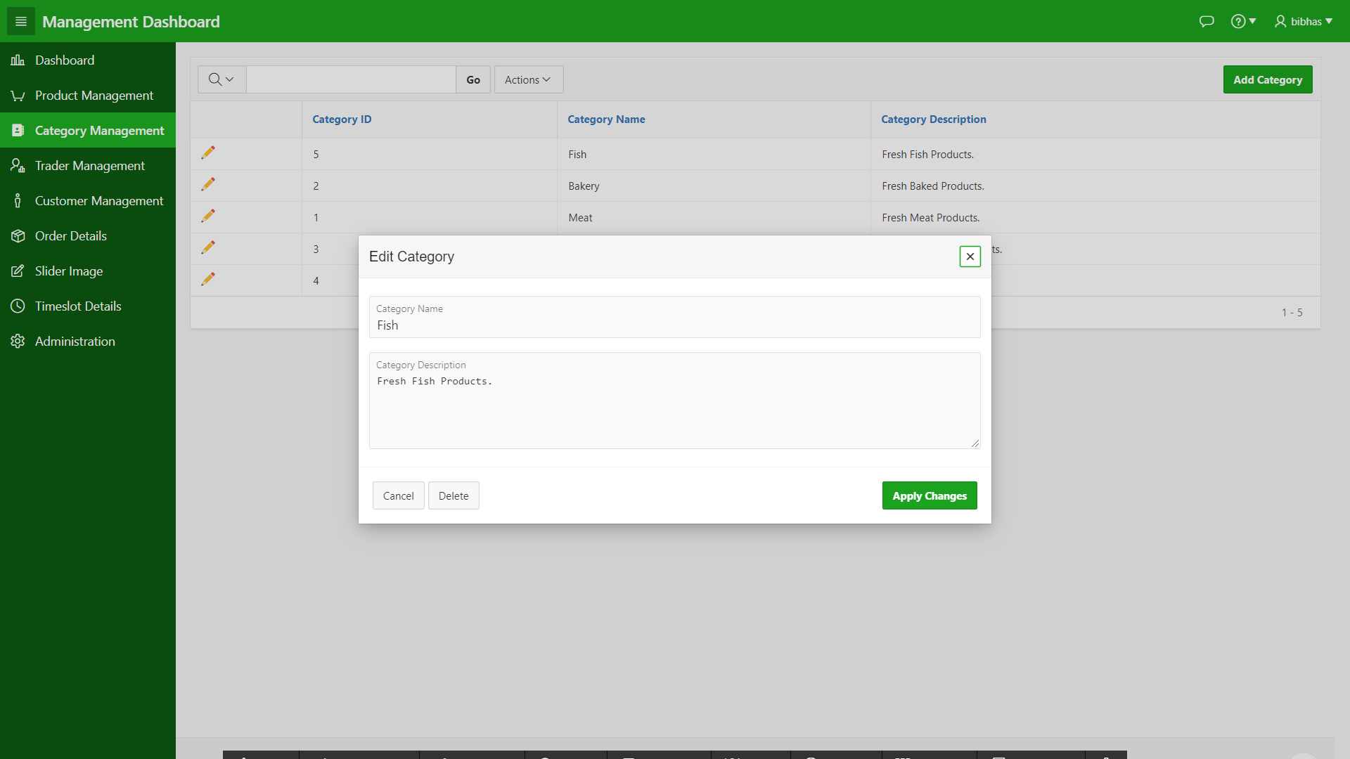

# Trader Management

You can view the interactive report on the trader management page where you have the option to add new trader or edit existing trader.

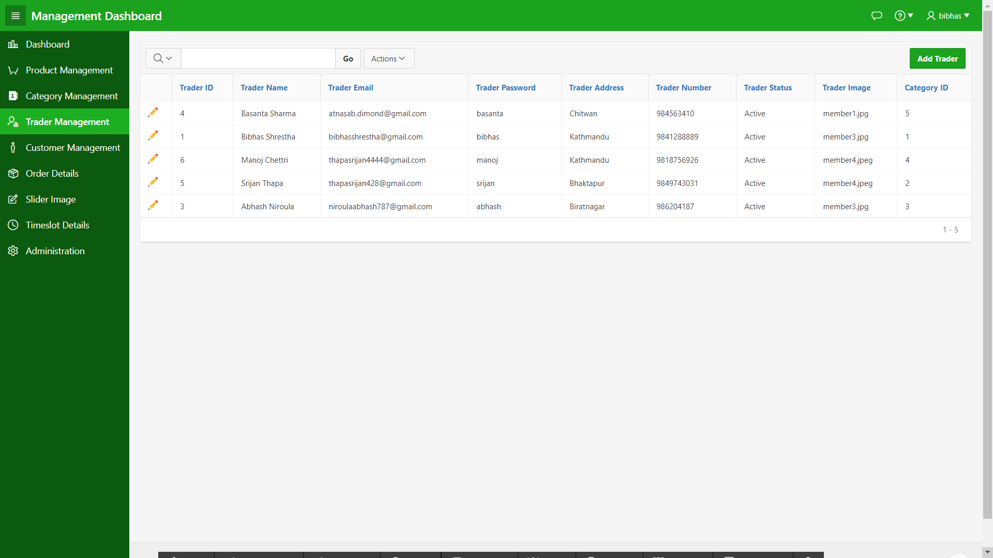

# Edit Trader

You can edit the trader after clicking on the pencil icon. A modal dialog page opens where the trader can be edited.

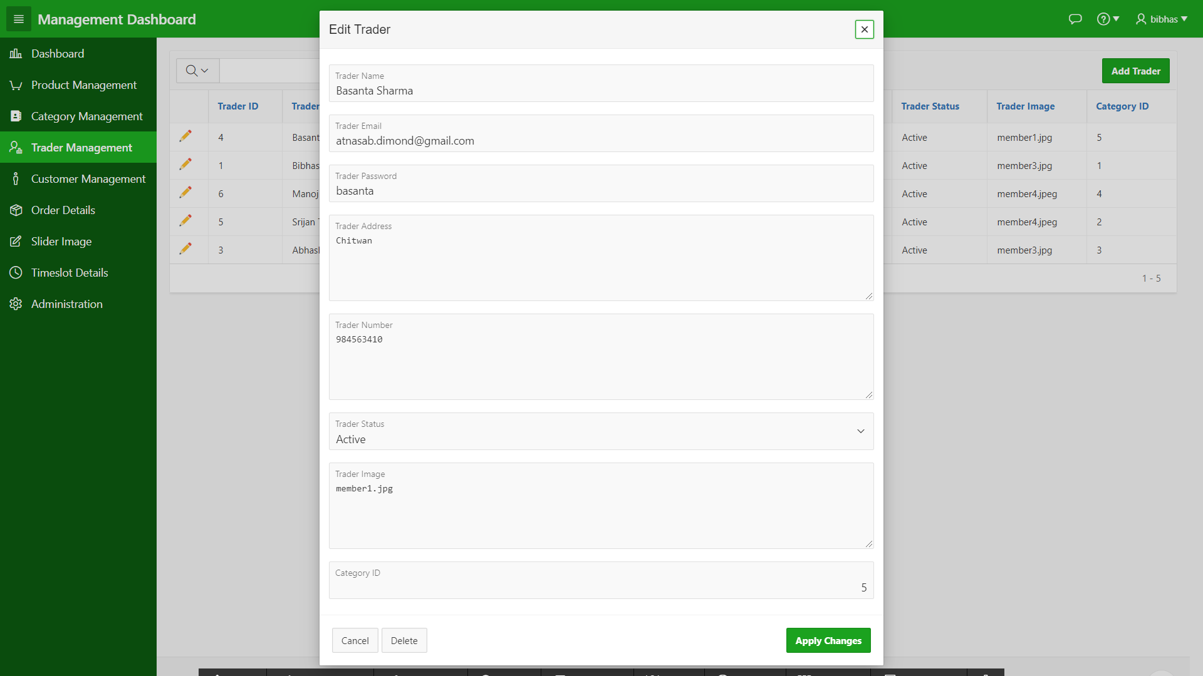

# Customer Management

You can view the interactive report on the customer management page where you have the option to add new customer or edit existing customer.

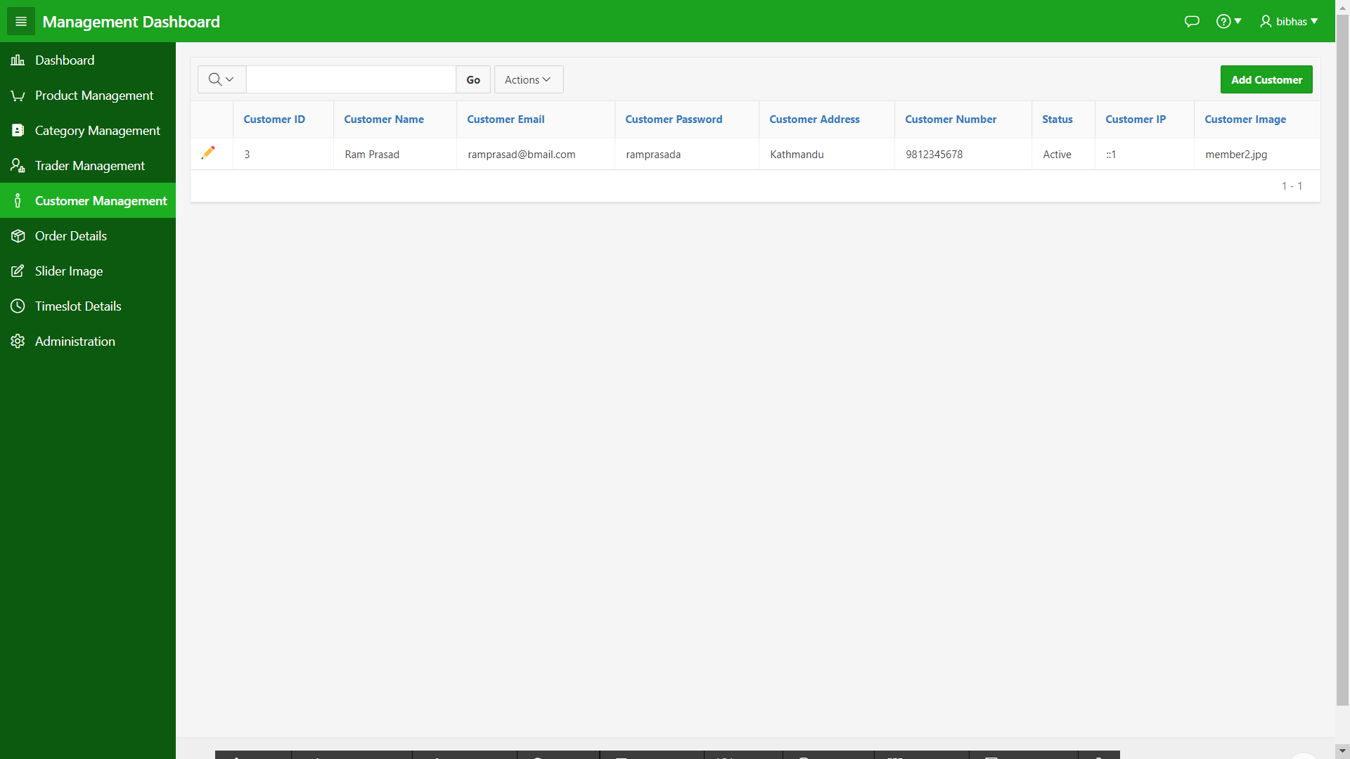

# Edit Customer

You can edit the customer after clicking on the pencil icon. A modal dialog page opens where the customer can be edited.

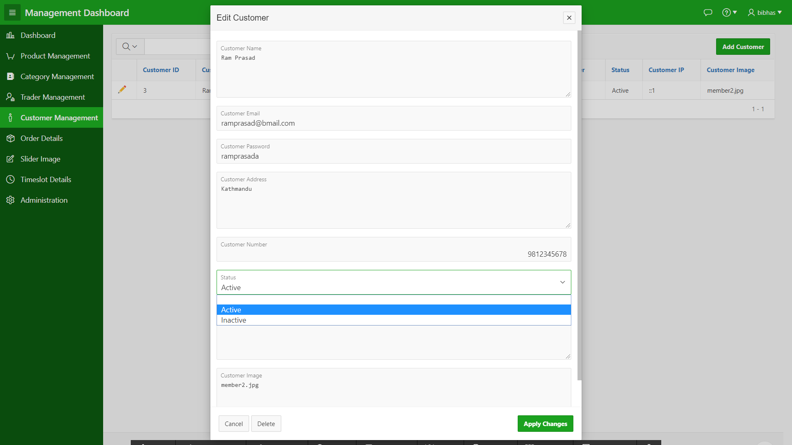

# Order Details

You can view the order detail where you can check product quantity, order date, order invoice.

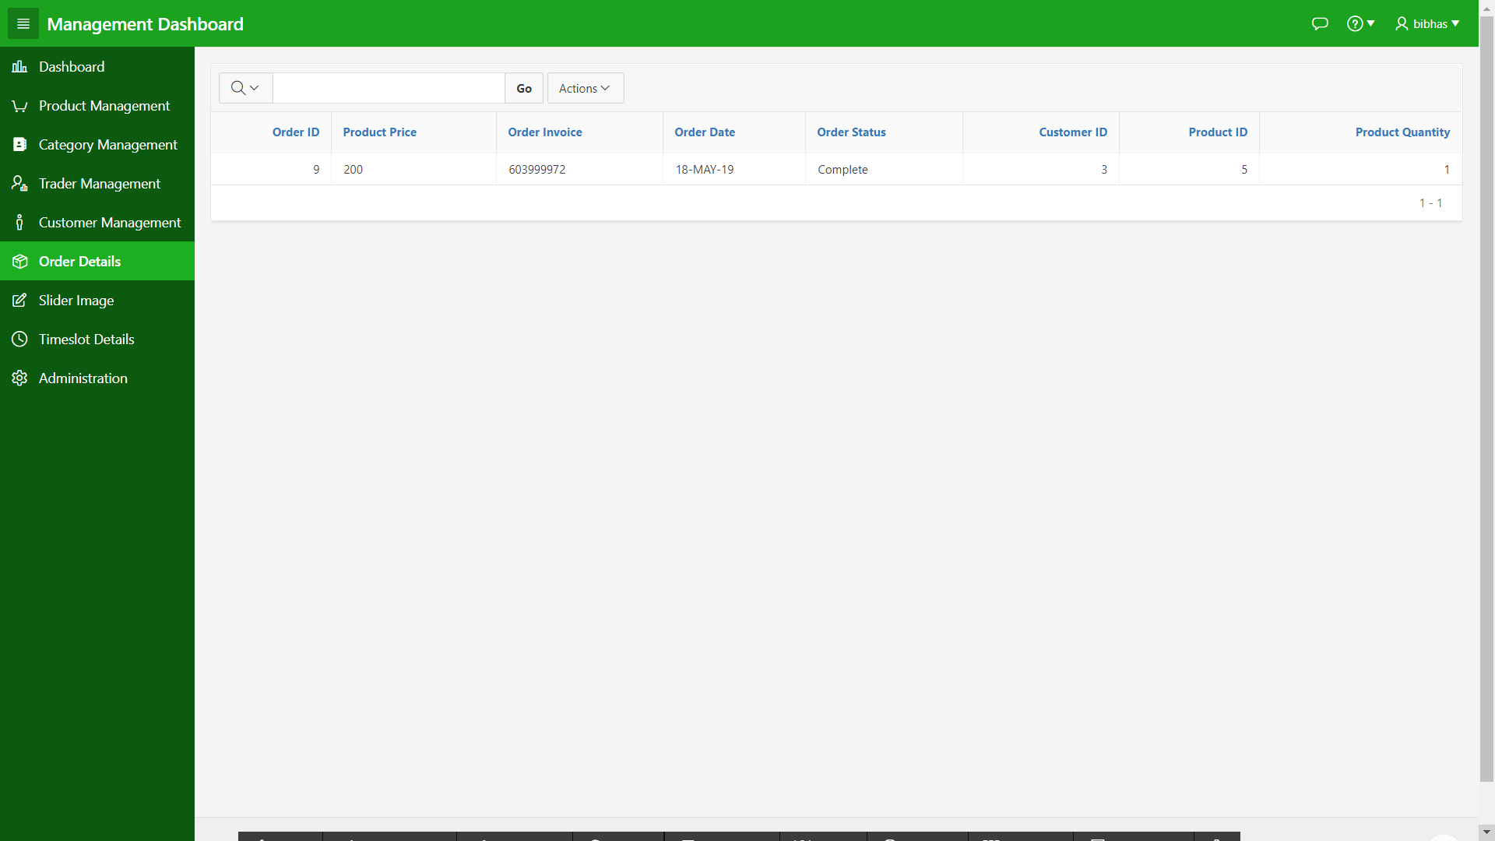

# Slider Image

You can add the slider image on the website image from this interactive report.

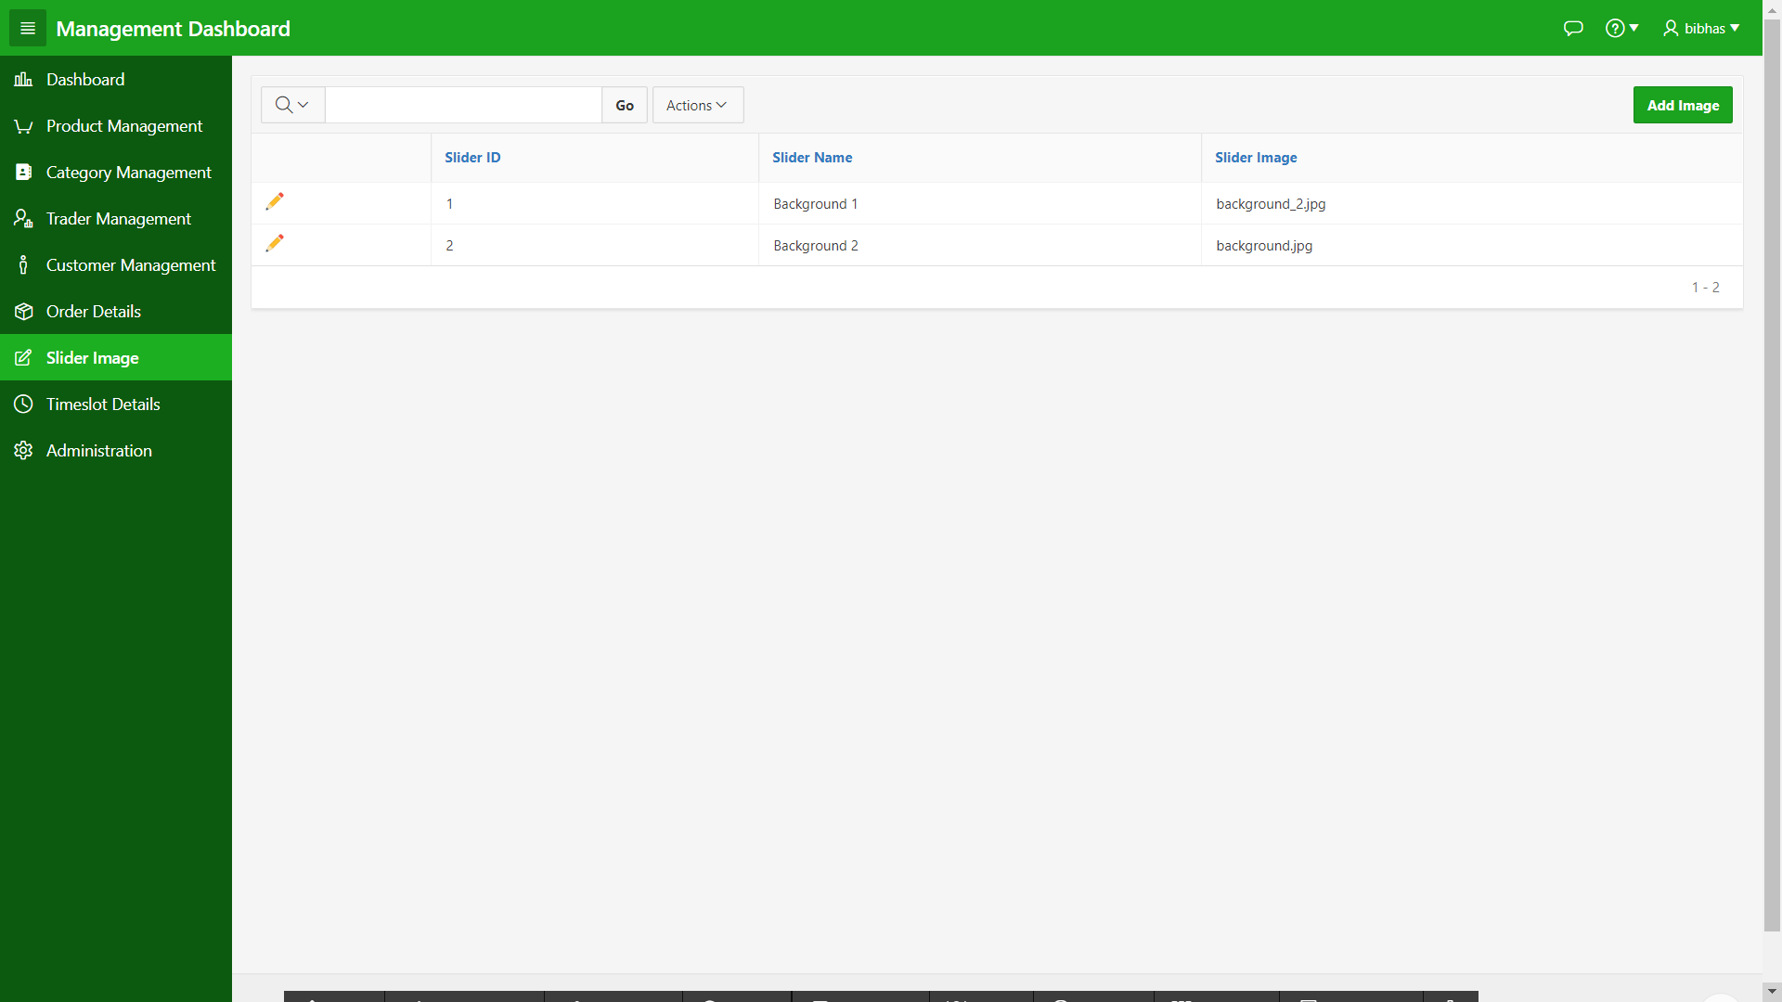

# Timeslot Details

You can view the timeslot details where you can check order invoice, date and time of the order.

# 

# Administration

You can configure the application, select the them and use access control from this page.

